**Thiruvalluvar university**

**Periyar ARTS COLLEGE**

**cuddalore – 607001.**



**DEPARTMENT OF COMPUTER APPLICATIONS**

**MACHINE LEARNING WITH PYTHON**

**Project Title :** Flight Delay Prediction For Aviation Industry Using Machine Learning

**Team Id :** NM2023TMID22782

**Team Leader :** RAGAVENI K(**68BAEE7B5960BE892BD4C391B41EC645**)

**Team member:** MAHA S (**1ED1E6A64C701488E53408370F5E8741**)

**Team member:** PADMASRI A(**A7985275587A45883B14ABFC27B7B221**)

**Team member:** DHANAM S(**CA8781DF50BC2BFA5104D56700C8F8B2**)

# INTRODUCTION

## Overview

Over the last twenty years, air travel has been increasingly preferred among travelers, mainly because of its speed and in some cases comfort. This has led to phenomenal growth in air traffic and on the ground. An increase in air traffic growth has also resulted in massive levels of aircraft delays on the ground and in the air. These delays are responsible for large economic and environmental losses. The main objective of the model is to predict flight delays accurately in order to optimize flight operations and minimize delays.

## Purpose

Using a machine learning model, we can predict flight arrival delays. The input to our algorithm is rows of feature vector like departure date, departure delay, distance between the two airports, scheduled arrival time etc. We then use decision tree classifier to predict if the flight arrival will be delayed or not. A flight is considered to be delayed when difference between scheduled and actual arrival times is greater than 15 minutes. Furthermore, we compare decision tree classifier with logistic regression and a simple neural network for various figures of merit.

# LITERACY SURVEY

## Existing system

Since flight delays cause multiple problems across the world, there has been a significant improvement in delay prediction model right from the 1990s. The quantity of the delay decreased the quality of marketing strategies. A delay in the departure or arrival of a domestic flight affects the operation of an international flight. A small amount of change in the delay value can be a massive amount of success for airport sectors.

## Proposed system

In the proposed system user gives the input for predicting the output, where they can give input as Flight Number, Month, Day of Month, Week, Origin, Destination, Schedule Departure Time, Schedule Arrival Time, Actual Departure Time then click to submit the output. Then the proposed system will predict the output as whether the flight will be delayed or on time based on the inputs given by the user.

# THEORITICAL ANALYSIS

## Block diagram

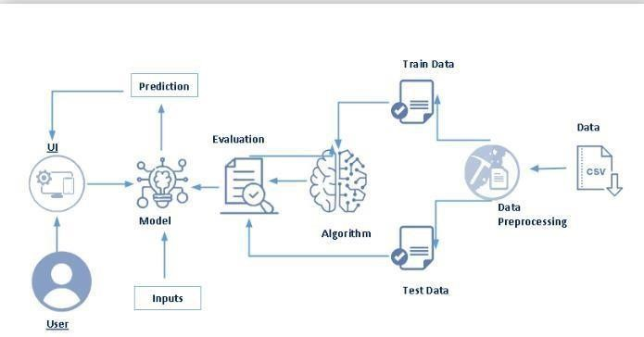

## Hardware and Software

* Laptop
* Anaconda Navigator
* Jupyter Notebook
* Spyder
* IBM Cloud

# EXPERIMENTAL INVESTIGATIONS

While working on the model we get to find out the calculations of flight delays are being carried out. Also, we get to know how a particular machine learning model will help finding out the delay process of a flight.

# FLOWCHART

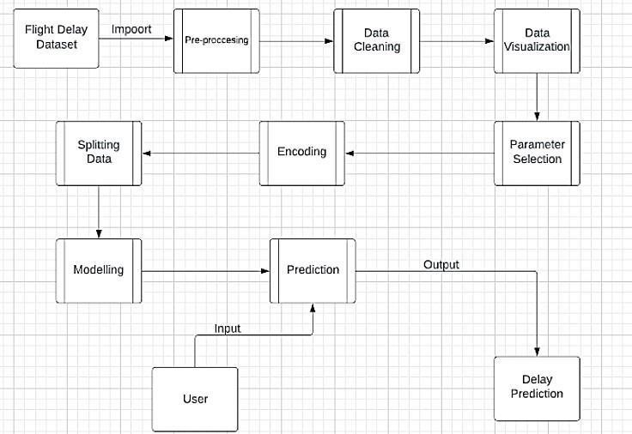

# RESULT

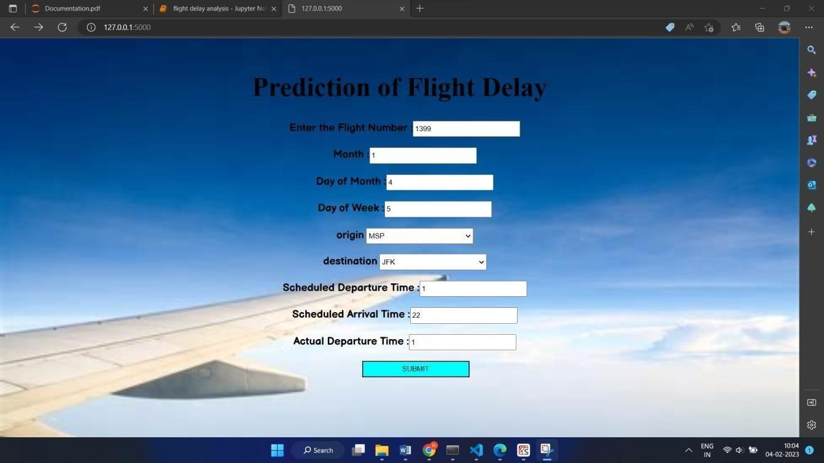

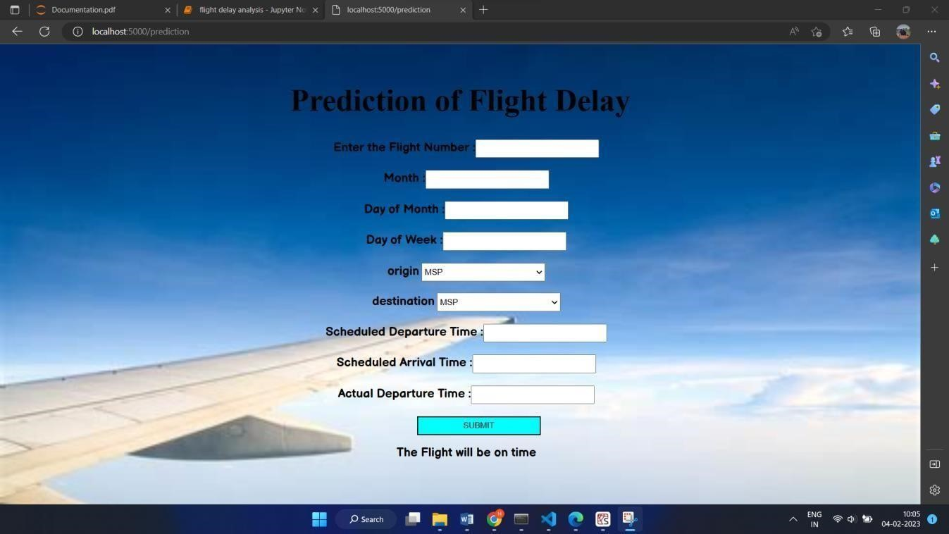

Here the actual and scheduled departure time is same the flight will be on time.

Now giving values as the flight will be get delayed the output will be,

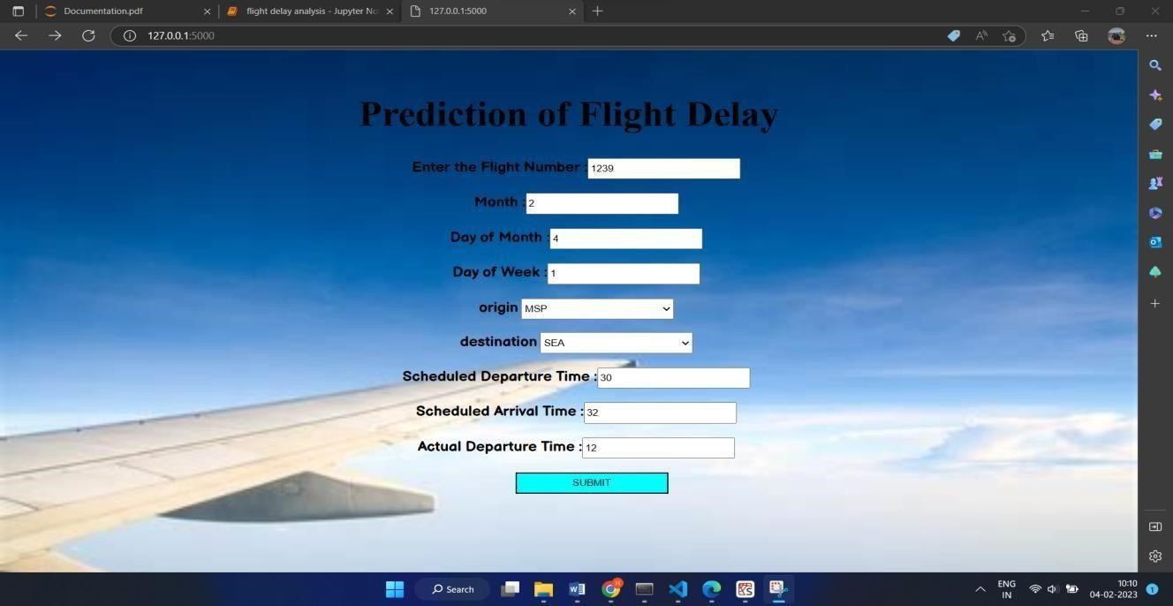

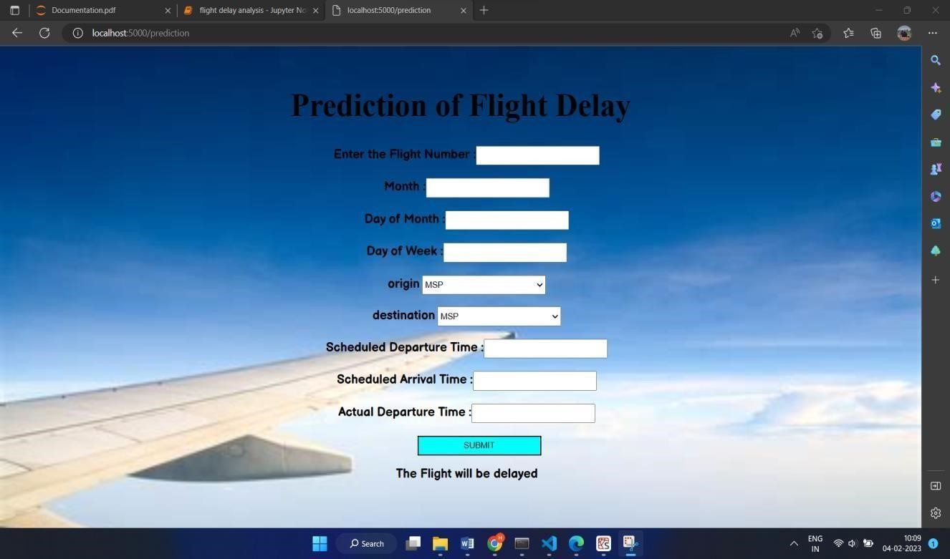

# ADVANTAGES AND DISADVANTAGES

**Advantage**: Using the flight delay system we can predict whether the flight will departure late when compared to the scheduled departure time.

**Disadvantage**: To use this system we need both scheduled departure time and actual departure time to calculate the delay.

# APPLICATIONS

This can be applied for customers who wait for confirmation if the flight will arrive or will get delayed through customer service for a long time. Customers will get to know their answer pretty quick also.

# CONCLUSION

Following this project, it is likely that the choice of approaches that can be utilised to produce notable results will be heavily influenced by the dataset's balance. Many machine learning models, such as Decision Tree Classifier, have been used to predict airplane arrival and delays. We were able to acquire a quick answer about the flight status thanks to IBM Cloud and the Flask application.

# FUTURE SCOPE

Many machine learning models can be used to forecast airline arrival delays, including Logistic

Regression, Random Forest Regression, Linear Regression, and its variation Boosted Linear Regression. Even these algorithms will be able to forecast delays with excellent accuracy when given the proper combination of input parameters. We can forecast arrival delay even without including departure delay as an attribute if weather and air traffic control information are made available. We can also estimate whether a flight will be delayed or cancelled depending on weather elements such as snow, rain, or storms.

# BIBLIOGRAPHY

SmartInternz student portal

YouTube

## APPENDIX

**Source code:**

**Jupyter notebook**

flight delay analysis.ipynb

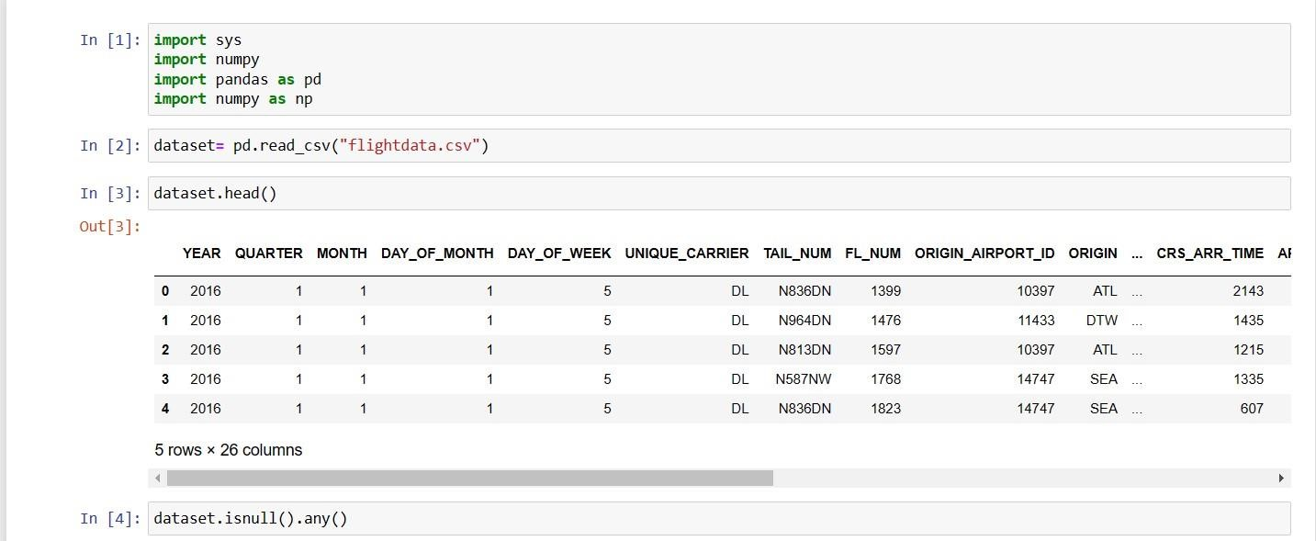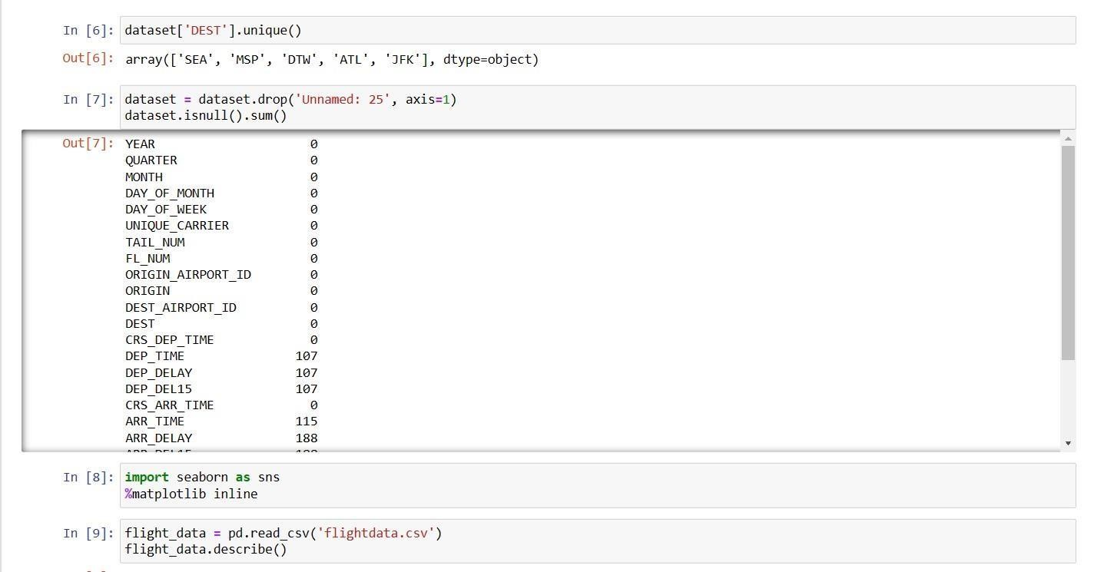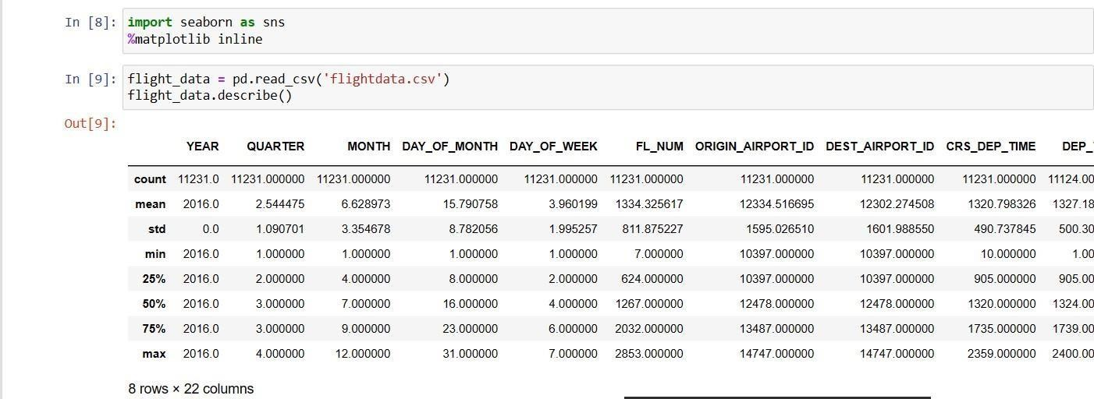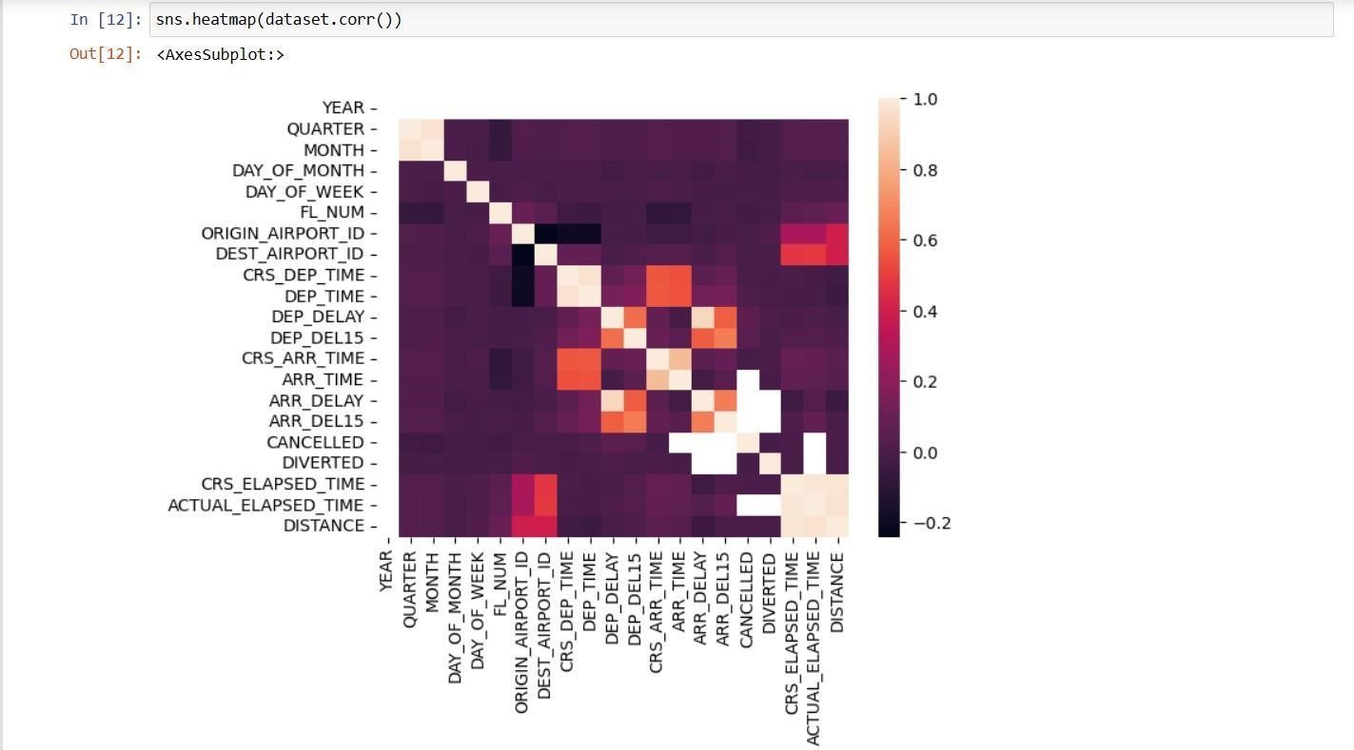

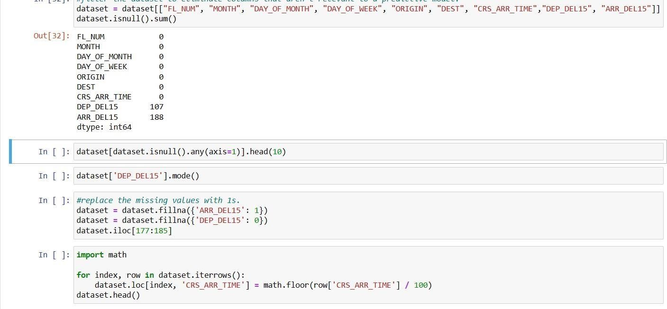

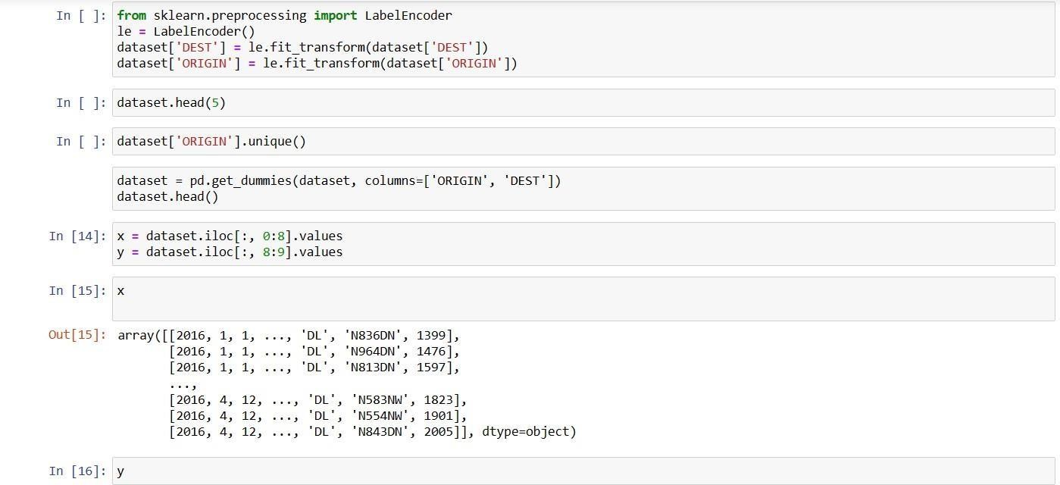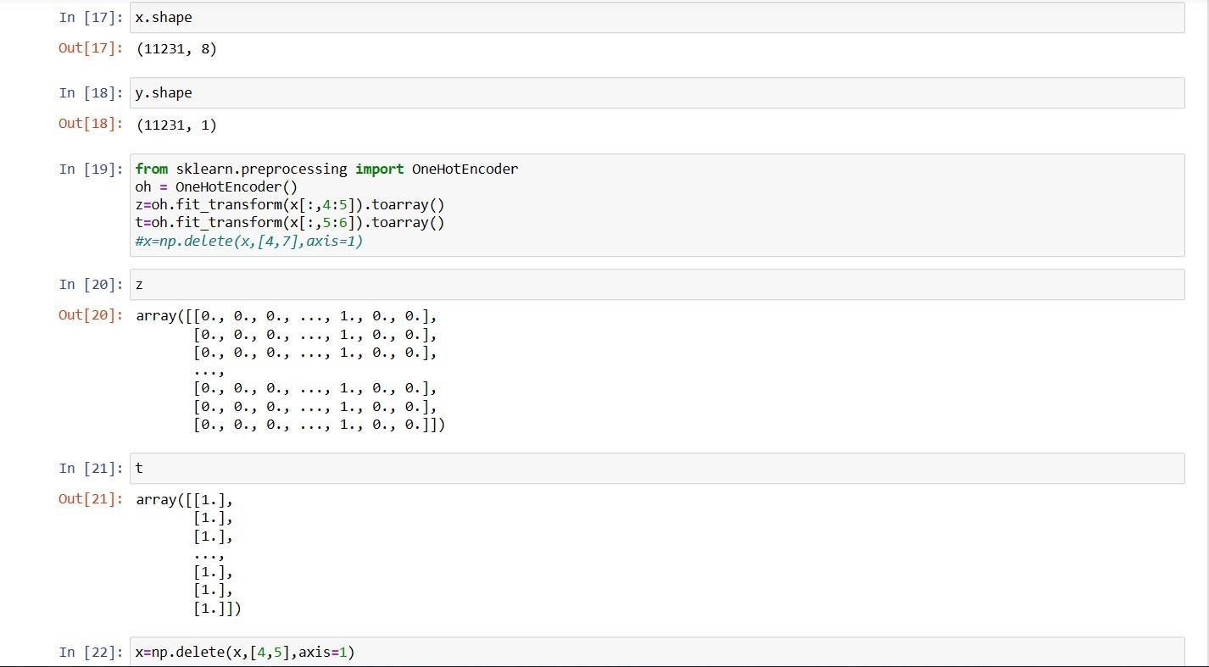

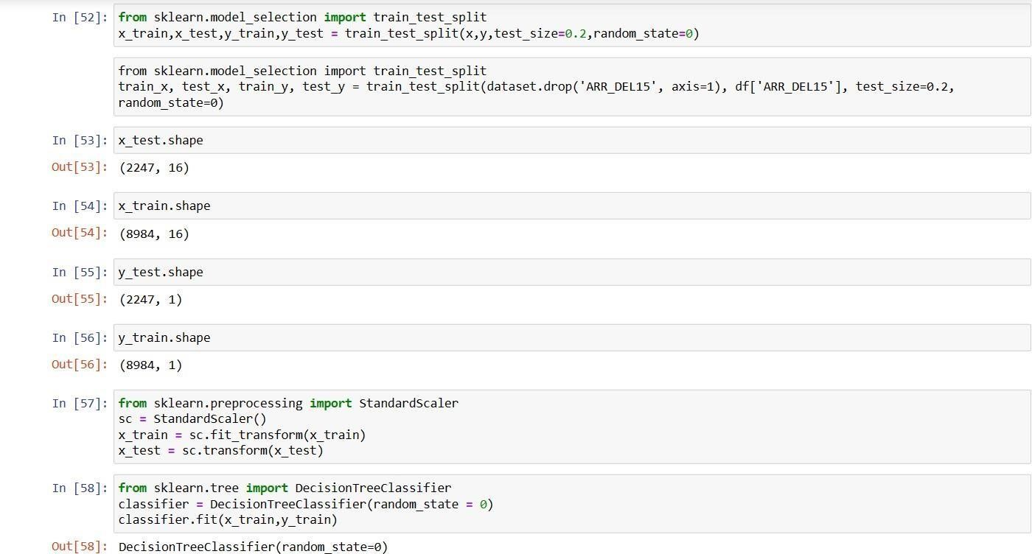

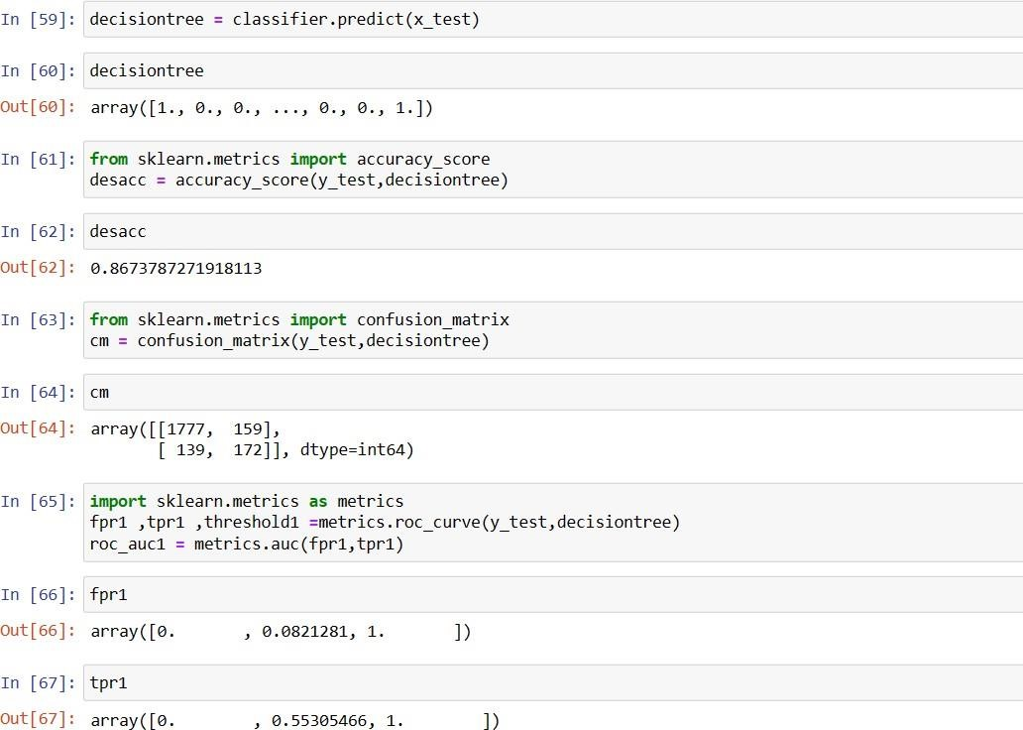

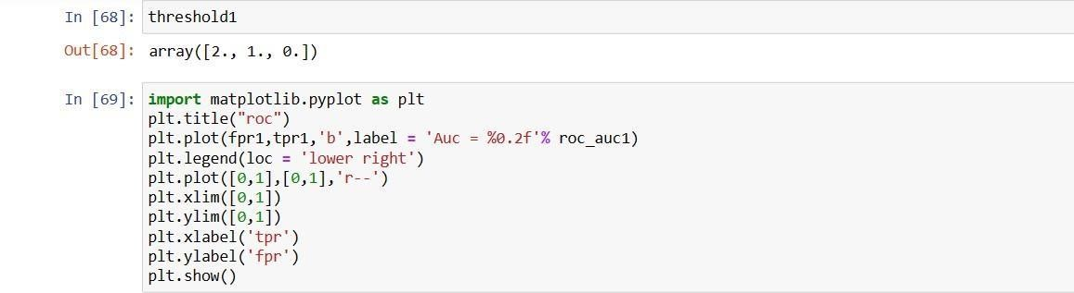



Index.html

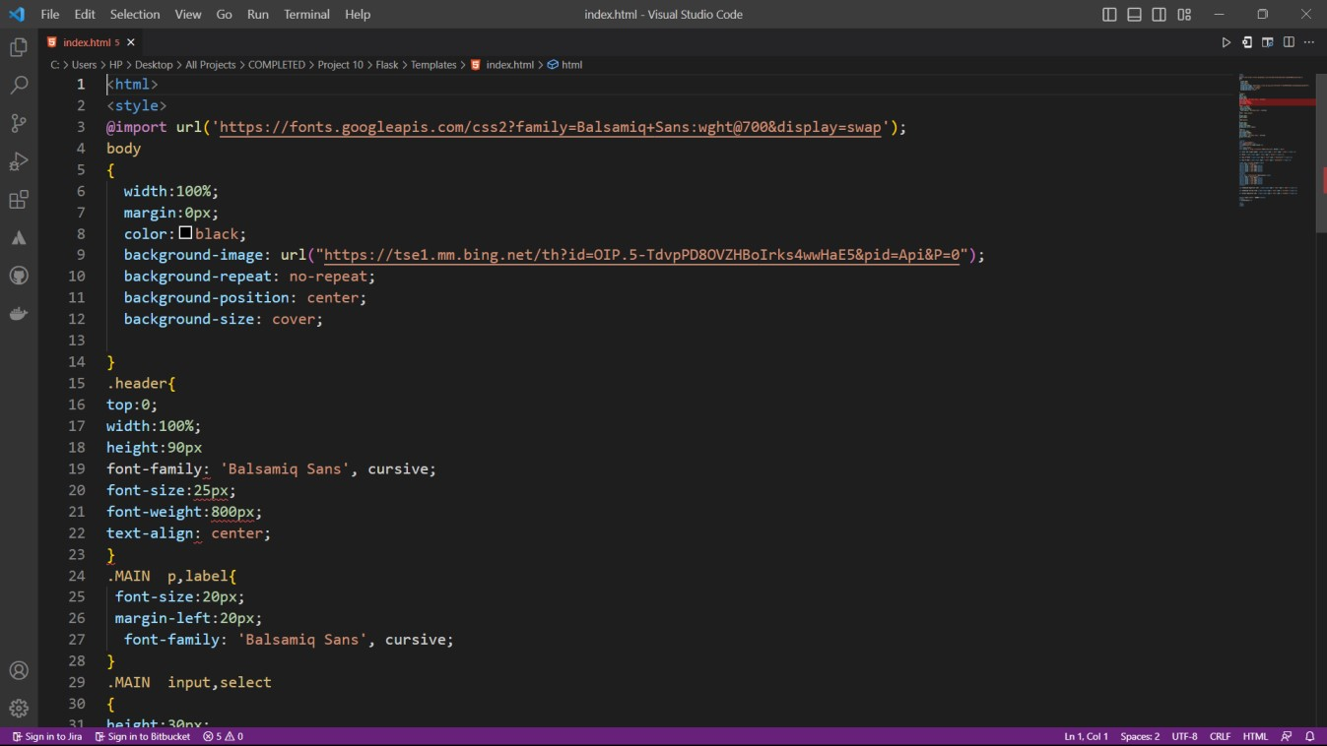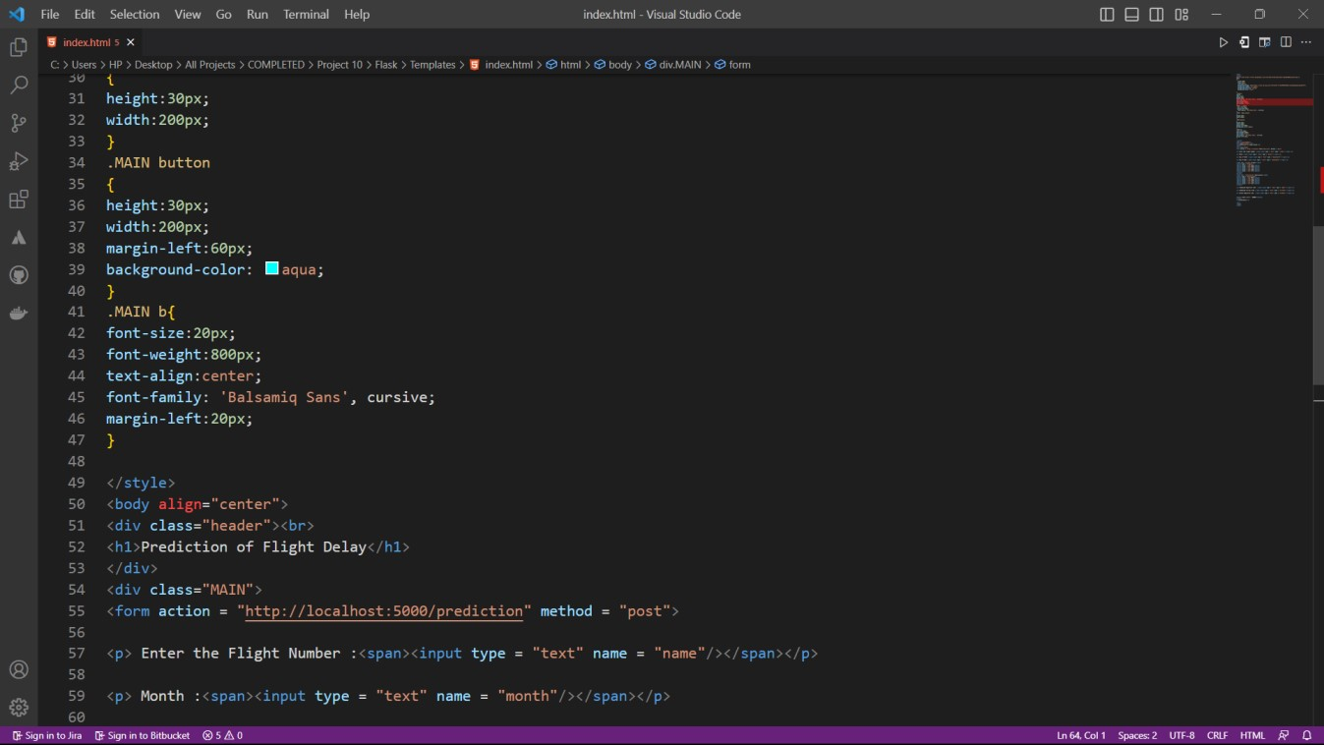

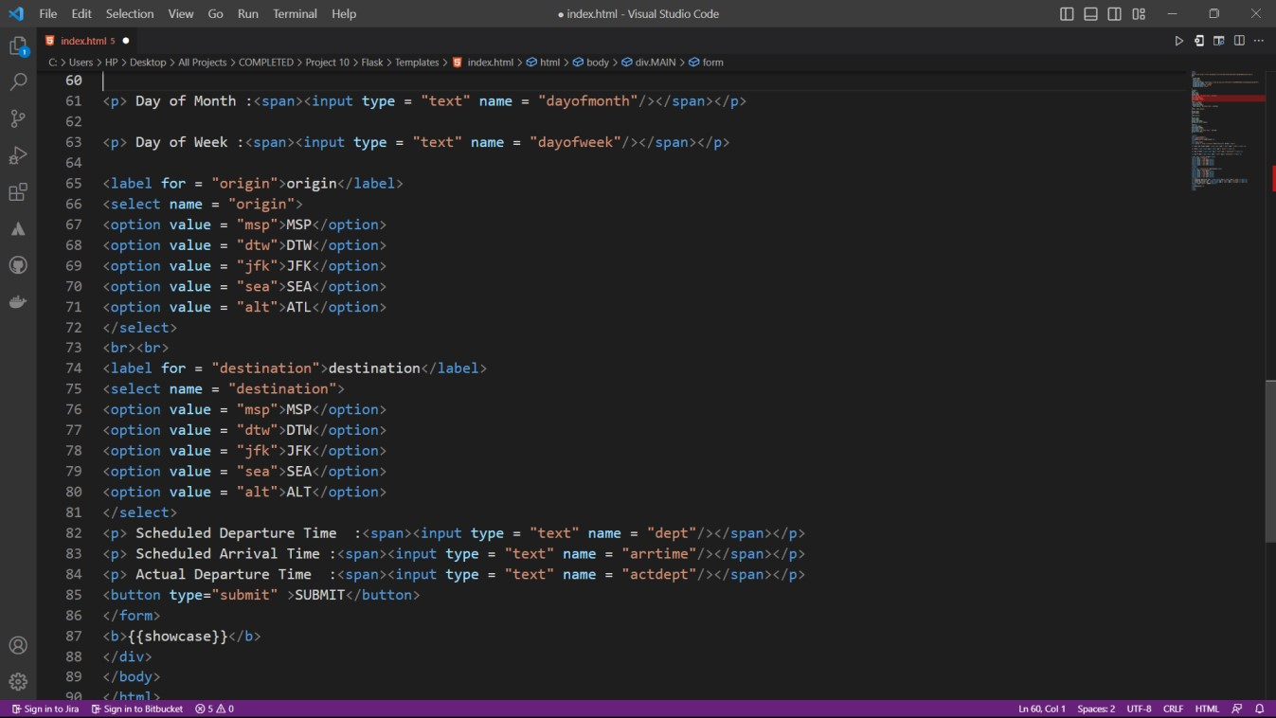

App.py

